Charolette Jackson
CIS-4350-125-Management Information Systems
Ahmed Mianoor
December 7,2025

Hotel booking demand
Data analysis of guest behavior and booking trends

Introduction
This analysis was made to provide hotel managers with a deeper understanding of their bookings while also reducing cancellations and highlights areas of their marketing strategies that might need improvement.
The analysis breaks down the hotel booking demand dataset from Kaggle that collected from two types of hotels: City hotels and resort hotels. Data has been collected from 2015 to 2017 and contains a multitude of variables such as: Cancellation status, lead times, arrival dates, types of customers, and average daily rate. This project’s purpose is to understand the patterns in which hotels are booked, the behavior of cancellations, in which season has the highest demand of bookings as well as the different customers and their characteristics. All of these factors play a role in hotel operations and contribute to hotel booking systems. Tableau public was used to display seven visuals to support seven different analytical questions using data visualization and descriptive analytics.

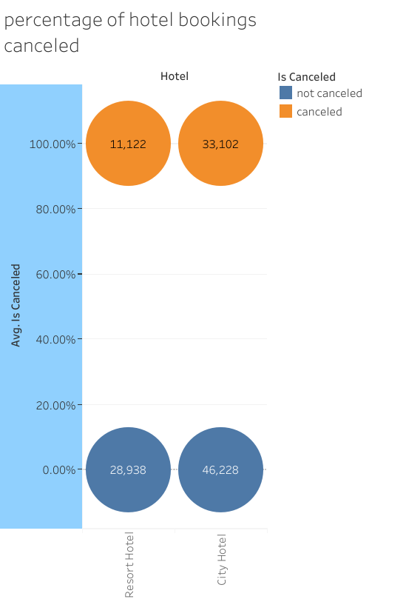
Question #1
What is the cancellation rate by hotel type?
Analysis
The rate at which hotel bookings are cancelled differs significantly based on hotel type. It’s shown from the data set that city hotels show a significantly higher rate of cancellations compared to resort hotels. Understanding the patterns in which hotels are canceled allows hotel managers to predict booking strategies and place cancellation policies in place to lessen the impact of revenue instability. In addition, managers can forecast staffing requirements with accuracy.
Figure 1. percentage of hotel bookings cancelled

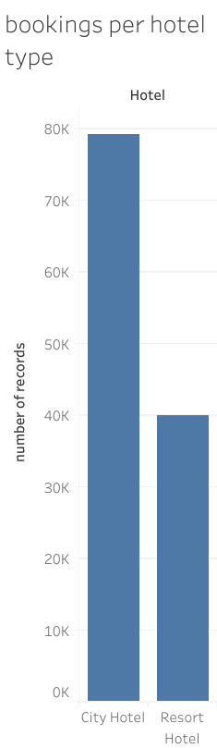
Question #2
Which type of hotel recieves moore bookings: city hotels or Resort hotels?
Analysis
The data set shows that city hotels are more likely to be booked compared to resort hotels. Many factors can be considered by this analsis. Business travel, tourism and city asseibility are likely contributions to this data. Resort Hotel mangers can benefit from this knowledge by planning and organizing marketing campaigns or events seasonally, while city hotel managers would benefit by planning and organizing year round packages to drive sales.

Figure 2. Bookings per hotel type
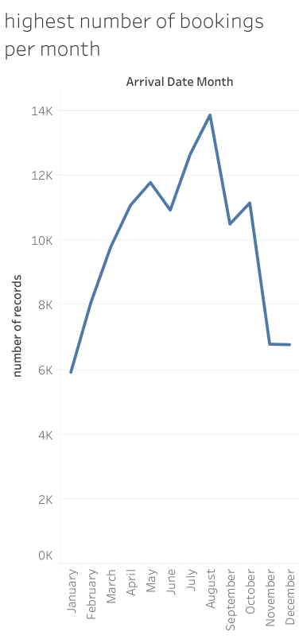
Question #3
Which months experience the highest number of bookings?
Analysis:
From the dataset it can be determined that july and august have the highest number of bookings. Summer seasons tend to have the higest number of travel during this time in many different countries. Hotels should anticipate and plan for staffing requirements and marketing strategies during this time. Also to hihglight opportunities for promotions and streamline packages for off season.
Figure 3. Highest number of bookings per month
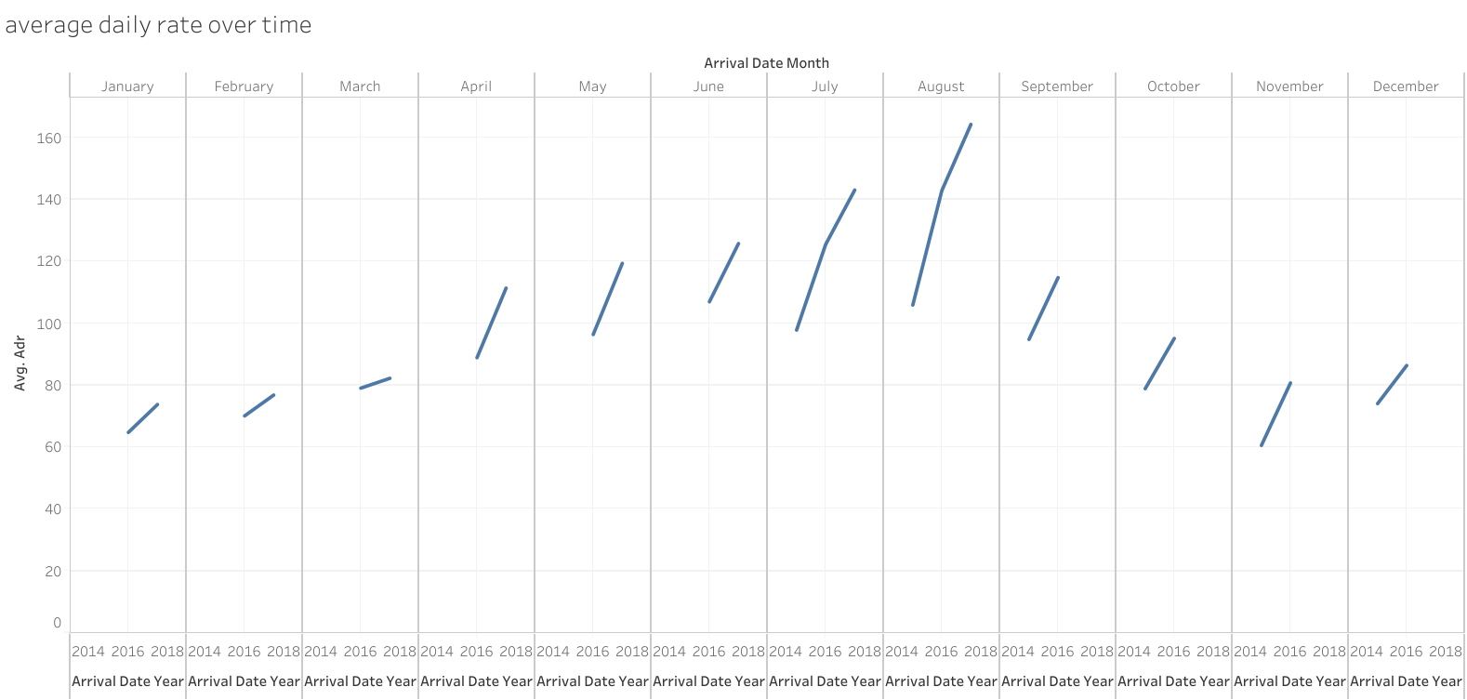
Figure 4. Average daily rate over time

Question #4
How does the daily average rate change over time?
Analysis:
The average daily rate changes over time as shown in figure 4. It can be derived from seasonal bookings which show higher prices during peak seasons and lower prices during off seasons. With this data, hotels can change and update pricing strategies and forcast their revenue. Based on demand, hotel managers can adjust room rates at anytime to fit their needs.
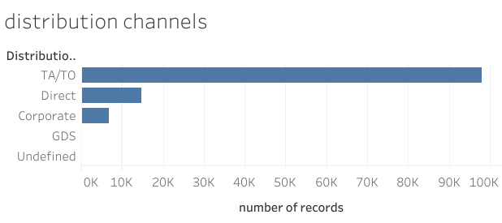
Figure 5. Distribution channels

Question #5
What distribution channels are used the most for hotels?
Analysis:
The distribution channels used the most tend to be Travel agents or Online Travel agencies. Direct bookings follow right after but make up a smaller portion of bookings. Hotel managers can benefit from creating and maintaining relationships with onine travel agencies to help optimize their listings and increase or improve their online presence. They can also increase revenue with the use of loyalty programs, discounts or promotions shown by agents.
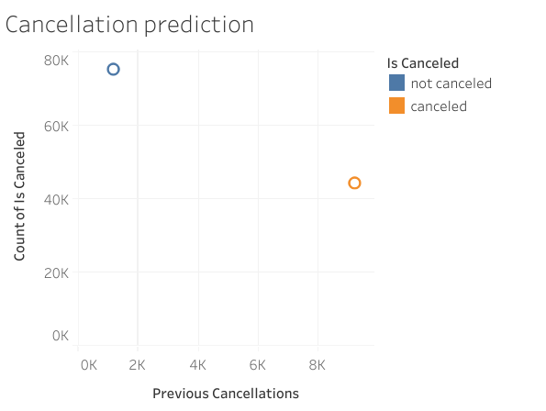
Figure 6. Cancellation predictions based on previously cancelled reservations

Question #6
Do customers with previously cancelled reservations tend to cancel again?
Analysis:
This analysis shows the relationship between previously canceled reservations and the chances of upcoming cancellations. Guests who have canceled in the past are more likely to cancel again in the future. With this information hotels can determine who is considered a high-risk customer and require deposits or cancellation policies to protect their revenue.

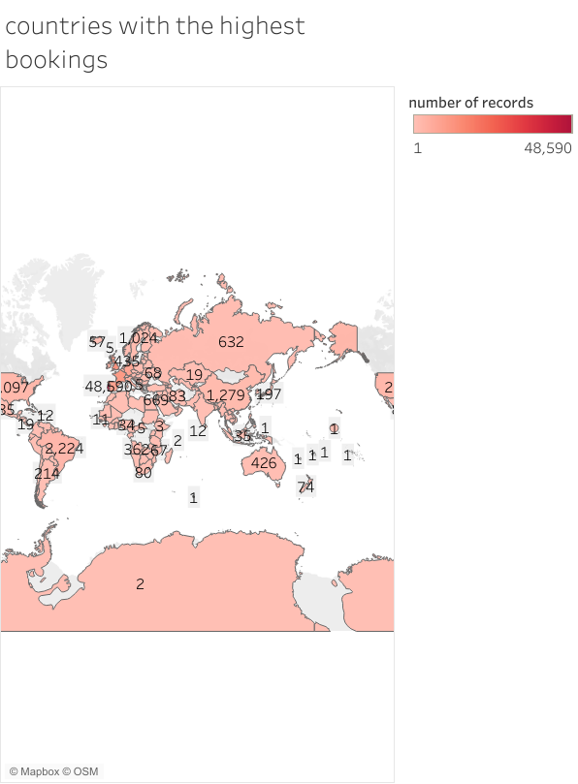

Figure 7. Countries with the highest bookings

Question #7
Which countries contribute to the highest number of guests and reservations?
Analysis:
From the dataset, guests tend to travel to most European countries. Countries that appear the most frequent include Portugal, the United Kingdom, France and Germany. Hotels can use this data to understand guest nationality and customize marketing strategies and programs for specific regions. In addition, they can accommodate guests with language barriers and increase customer satisfaction and comfortability.

Conclusion
In conclusion, this analysis of the data set for hotel booking demands provides valuable insights into the behaviors of guests and their reasonings for cancellations, pricing patterns, guest origins, and the preference of booking channels, The findings highlight the seasonal trends that separate the unique qualities of resort hotels and city hotels.
These patterns can help streamline hotel operations in many different ways. Forecasts allow hotel management to predict staffing needs. This data set also can help reduce cancellations, highlight average daily rates based on seasonality, and improve marketing strategies. Data analytics can help to make decisions easier by information of revenue and customer needs. Data driven approaches will increase competitive awareness and success.

References

Mostipak, J. (2019). Hotel booking demand. Kaggle.
https://www.kaggle.com/datasets/jessemostipak/hotel-booking-demand

